Day 1 Lab: Managing IT Operations Runbooks with GitHub
Day 1

Business scenario
Your IT Operations team maintains troubleshooting runbooks for common incidents. Engineers sometimes update documents locally, making it difficult to track changes, review procedures, or collaborate safely.
You will create a centralized GitHub repository, add a CPU incident runbook, update it using a branch, submit the changes for review, and create an issue to track an operational problem.
Expected outcome
A version-controlled operational runbook and a tracked incident.
Environment
Web browser and GitHub account. No cloud account or Python installation needed.
Difficulty
Beginner-friendly
Deliverable
One repository, one feature branch, one pull request, and one issue.

1. Learning objectives
By the end of the lab, participants will be able to:
- Explain why GitHub is useful for IT Operations.
- Create and organize a repository.
- Store operational documentation in Markdown.
- Create a branch to isolate changes.
- Commit changes and understand version history.
- Submit a pull request for review.
- Create and manage an issue for an operational incident.
- Explain how these practices support automation and AIOps.

2. Lab schedule — 120 minutes
Time | Activity
0–10 min | Understand the scenario and check prerequisites
10–25 min | Create a GitHub repository
25–45 min | Create the initial operational runbook
45–65 min | Create a branch and update the runbook
65–80 min | Review commit history and compare changes
80–100 min | Open and merge a pull request
100–112 min | Create an incident-tracking issue
112–120 min | Validate results and complete the knowledge check
The lab uses the GitHub web interface throughout, so participants can complete it without installing Git. The same workflow can later be repeated using Git commands.

3. Prerequisites
Before starting, each participant needs:
- A laptop with a modern web browser and internet access.
- A GitHub account they can sign in to.
- Permission to create a personal repository, or access to a training organization where repositories can be created.
- A browser window in which they can access GitHub.
No AWS account, Kubernetes cluster, production logs, paid GitHub plan, or local software installation is required for this exercise.
Important: If the organization blocks personal GitHub accounts or repository creation, the trainer should arrange an approved training organization or repository beforehand.

4. Hands-on instructions

Participant progress checklist
0 of 8
Sign in to GitHub and create the repository
Create the initial CPU incident runbook
Create a feature branch
Update the runbook with diagnostic and recovery steps
Review the commit history and changes
Create and merge a pull request
Create an incident-tracking issue
Validate the completed lab

Step 1 — Create your GitHub repository (15 minutes)
Objective: Create a central location for the IT Operations team's runbooks.
- Open GitHub.
- Sign in to your account.
- Click the + icon in the upper-right corner.
- Select New repository.
- Enter the following values.
Setting | Value
Repository name | aiops-operations-runbooks
Description | Version-controlled runbooks for IT operations and incident response
Visibility | Public or Private, according to the training policy
Add a README file | Enable
.gitignore | No selection needed
License | No selection needed
6. Click Create repository.
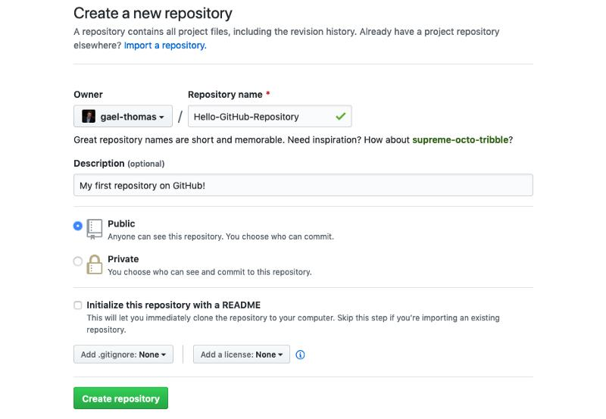
freecodecamp.org
Expected result: A repository named aiops-operations-runbooks appears with a README.md file.
Your repository URL will look like this:
https://github.com/YOUR-USERNAME/aiops-operations-runbooks
Replace YOUR-USERNAME with your own GitHub username. Do not use another participant's URL.
What have you created?
- A repository is a place to store project files and their version history.
- A README explains the purpose of the repository.
- Public repositories are visible to everyone; private repositories restrict access to authorized users.
For real operational documentation, use private repositories and follow organizational security policies. Do not publish passwords, internal hostnames, customer data, or production credentials.
Checkpoint: Open the repository and confirm that README.md is visible.

Step 2 — Create your first operational runbook (20 minutes)
Objective: Store a basic incident response procedure in GitHub.
In IT Operations, a runbook is a documented sequence of checks and actions used to investigate and resolve a known operational problem.
For this exercise, you will create a runbook for a server reporting high CPU utilization.
Part A: Create the file
- In your repository, click Add file.
- Select Create new file.
- Enter this filename:
runbooks/high-cpu-utilization.md
GitHub will create the runbooks directory as part of the file path if it does not already exist.
4. Copy the following content into the editor.

# Runbook: High CPU Utilization

## 1. Purpose

This runbook describes the initial investigation of a server
reporting unusually high CPU utilization.

## 2. Symptoms

- CPU utilization remains above the expected operating range.
- Application response times increase.
- Monitoring systems generate CPU utilization alerts.
- Users report slow application performance.

## 3. Initial Checks

1. Confirm the alert and affected host.
2. Check whether the condition is persistent or temporary.
3. Review CPU utilization trends.
4. Check for recent deployments or configuration changes.
5. Identify affected applications and business services.

## 4. Investigation Notes

Record the following information:

- Incident ID:
- Affected host:
- First observed time:
- Current CPU utilization:
- Recent changes:
- User impact:

## 5. Escalation

Escalate to the responsible application or infrastructure
team if the issue persists or the business impact increases.

## 6. Safety

Do not terminate processes or restart production services
without authorization and impact assessment.
- Scroll to the commit section at the bottom of the page.
- Enter the commit message:
Add initial high CPU utilization runbook
- Select Commit directly to the main branch.
- Click Commit changes.
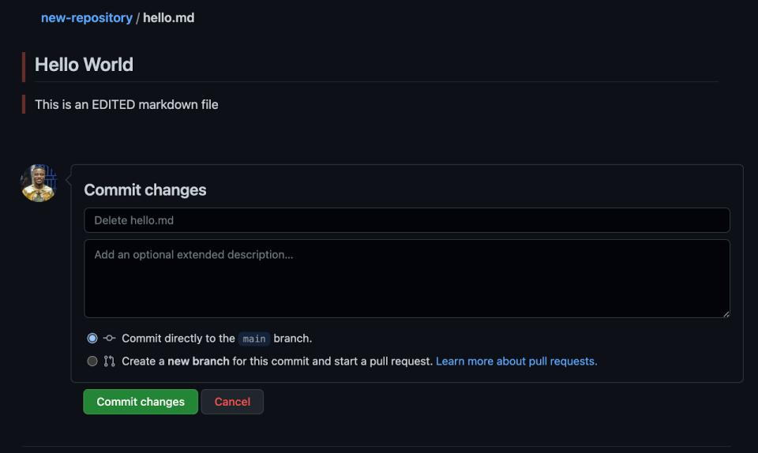
hackr.io
Expected result: The repository displays the new file runbooks/high-cpu-utilization.md.
Technical explanation
- Markdown is a lightweight text format used for documentation.
- The # character creates a heading.
- The - character creates a bullet point.
- Numbered lists are useful for procedures that must be followed in order.
- A commit records a snapshot of changes in the repository's history.
Operations connection: If an engineer updates this runbook, the team can see what changed and when and who changed it. This reduces dependence on undocumented procedures or files stored on individual laptops.
Checkpoint: Open the runbook and verify that the headings and numbered steps display correctly.

Step 3 — Create a feature branch (20 minutes)
Objective: Modify an operational procedure without directly changing the main branch.
Imagine that your operations team wants to improve the runbook by including diagnostic commands and a recovery checklist.
In a collaborative environment, it is good practice to prepare the changes in a separate branch and submit them for review.
Part A: Create the branch
- Return to the repository's Code page.
- Find the branch selector, which should display main.
- Click the branch selector.
- Type the following branch name:
feature/improve-cpu-runbook
5. Select the option to create a new branch with that name from main.
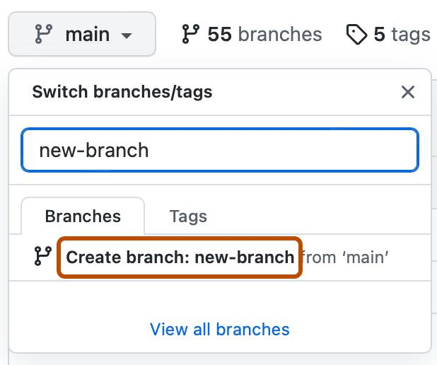
docs.github.com
6. Confirm that the repository now displays feature/improve-cpu-runbook as the current branch.
What is a branch?
A branch is an independent line of development within the repository. It allows you to make and review changes without immediately incorporating them into the main branch.
For this exercise:
- main contains the currently accepted runbook.
- feature/improve-cpu-runbook contains your proposed improvements.
Part B: Open the runbook for editing
- While on feature/improve-cpu-runbook, open runbooks/high-cpu-utilization.md.
- Click the pencil icon (Edit this file).
- Add the following sections to the end of the existing file.

## 7. Diagnostic Commands

Use only commands approved for your operating system and
organizational environment.

### Linux examples

Check overall system load:

uptime

Identify CPU-intensive processes:

ps -eo pid,comm,%cpu,%mem --sort=-%cpu | head

Review memory usage:

free -h

These commands are examples for Linux systems. Interpret
their output in the context of the affected workload.

## 8. Recovery Checklist

- [ ] Confirm the suspected cause.
- [ ] Check whether a recent deployment contributed to the issue.
- [ ] Obtain the required authorization before remediation.
- [ ] Apply an approved corrective action.
- [ ] Verify that CPU utilization and application response times improve.
- [ ] Record the resolution and relevant evidence.

## 9. Post-Incident Review

Document the root cause, customer impact, corrective action,
and preventive measures after the incident is resolved.
4. Enter the commit message:
Improve CPU runbook with diagnostics and recovery checklist
- Select the option to commit the changes to your current feature branch.
- Click Commit changes.
Expected result: Your feature branch now contains the enhanced runbook, while main still has the original version.
Why this matters for operations
A branch allows the team to propose changes to a troubleshooting procedure before making them the accepted standard. The review process helps catch unsafe or incomplete instructions.
Safety note: The diagnostic commands are illustrative and intended for Linux. The recovery checklist deliberately requires authorization before corrective actions. Do not run unapproved commands or terminate production processes as part of this lab.
Checkpoint: Verify that the feature branch is selected and that the updated file contains sections 7, 8, and 9.

Step 4 — Review the commit history and differences (15 minutes)
Objective: Learn how to trace changes to operational documentation.
- Open runbooks/high-cpu-utilization.md on your feature branch.
- Locate the file's History option. Depending on the GitHub interface, you may find it in the file view or its menu.
- Open the history.
- Identify the two commits you created:
  - Add initial high CPU utilization runbook
  - Improve CPU runbook with diagnostics and recovery checklist
- Open the second commit.
- Inspect the diff, which highlights the additions and removals made by that commit.
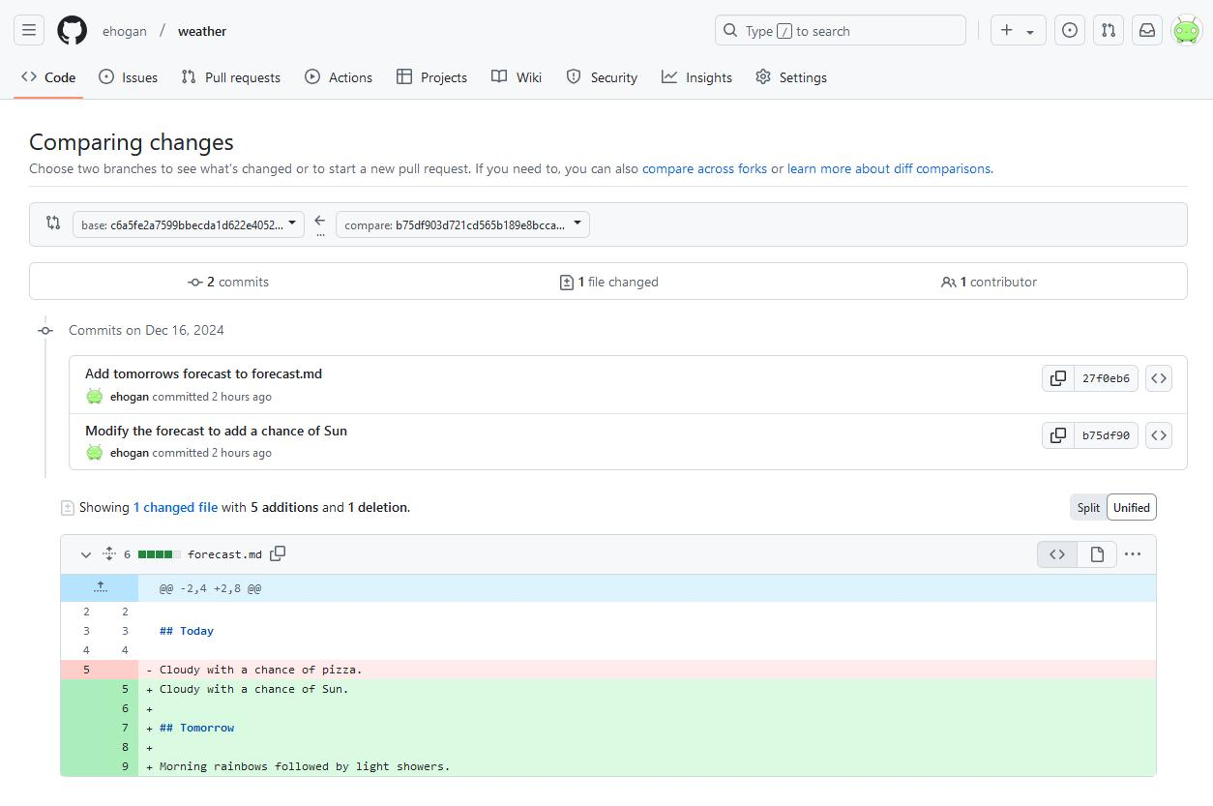
metoffice.github.io
Understand the output
GitHub concept | Meaning in this lab
Commit history | Shows recorded changes over time
Commit message | Describes the intent of a change
Diff | Shows lines added, removed, or modified
Author and timestamp | Help identify who made a change and when
Branch | Identifies the line of development containing the change
Operations scenario: Suppose an engineer changes an escalation step and the new procedure causes confusion during an incident. The team can inspect the change history to identify what was changed and discuss whether the procedure should be corrected.
Checkpoint: You should be able to identify the commit that introduced the diagnostic commands and recovery checklist.

Step 5 — Submit a pull request and merge the change (20 minutes)
Objective: Practise peer review and controlled changes.
A pull request (PR) proposes that changes from one branch be incorporated into another branch. It provides a place to discuss the change, review its diff, and decide whether it should be merged.
Part A: Open a pull request
- Select the Pull requests tab in the repository.
- Click New pull request.
- Set the branches as follows:
  - Base: main
  - Compare: feature/improve-cpu-runbook
- Review the displayed differences.
- Click Create pull request.
- Enter the title:
Improve high CPU utilization runbook
7. Add the following description:
Adds Linux diagnostic command examples, a recovery checklist, and post-incident review guidance. The procedure emphasizes authorization before remediation.
8. Click Create pull request.
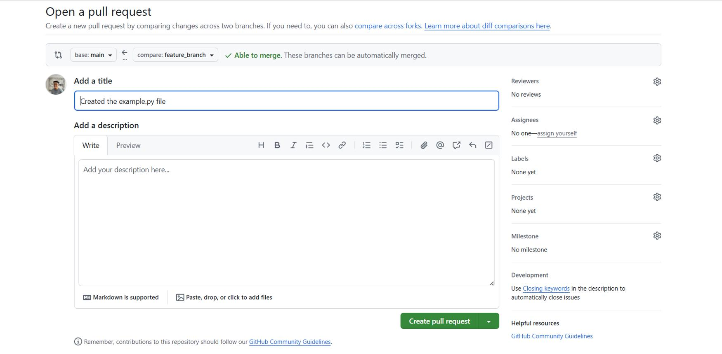
thedataschool.co.uk
Part B: Review the pull request
- Open the Files changed tab.
- Confirm that the new sections are present.
- Review the diagnostic commands and recovery checklist.
- Check that no credentials, secrets, or sensitive operational information have been introduced.
- If the repository allows it, add a review comment or ask a fellow participant to review the change.
Part C: Merge the pull request
For this introductory exercise, participants can merge their own pull request if repository permissions allow it and the displayed checks permit merging.
- Open the pull request's Conversation tab.
- Click Merge pull request if the button is available.
- Confirm the merge.
- Return to the main branch.
- Open runbooks/high-cpu-utilization.md.
- Verify that the diagnostic and recovery sections now appear on main.
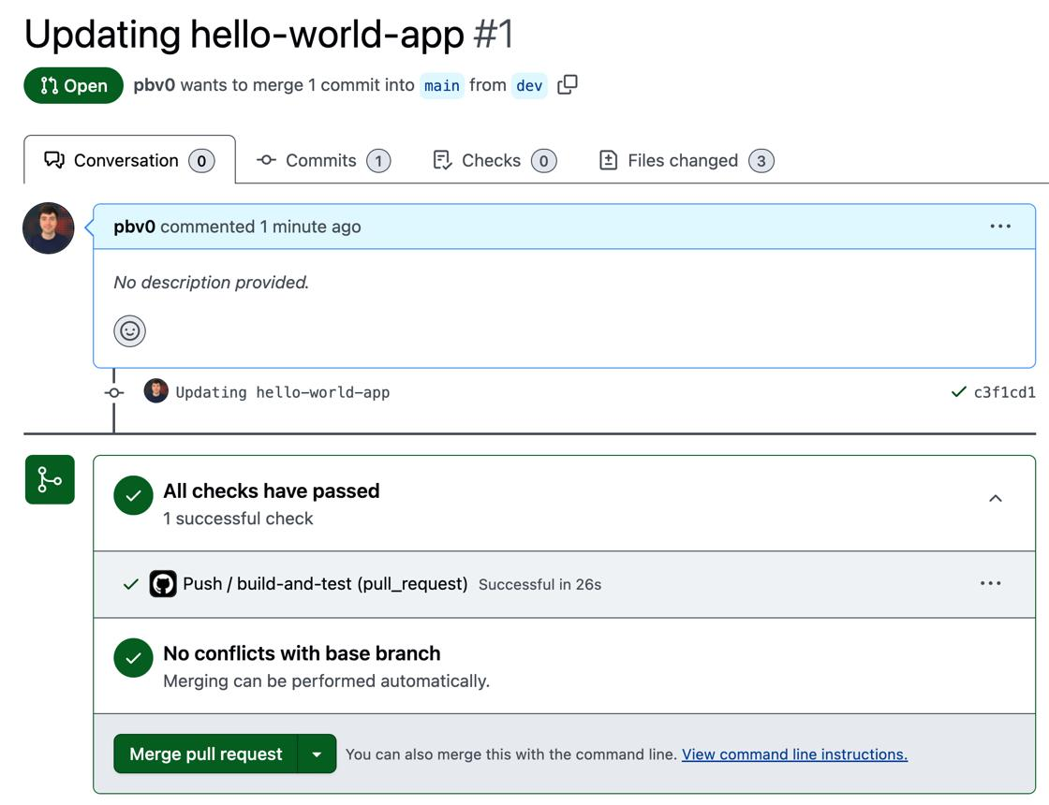
apps-cookbook.dev
If merging is blocked: The repository may require an approval, a passing status check, or a different permission level. Do not change organizational branch protection settings. Ask the trainer or repository administrator to help, and continue to the next step.
Important learning point: A pull request is the proposal and review process; the merge is the action that incorporates the changes. Merely opening a pull request does not update main.
Checkpoint: The improved runbook must be visible on main after a successful merge.

Step 6 — Create an incident-tracking issue (12 minutes)
Objective: Track an operational problem separately from the runbook documentation.
GitHub Issues can be used to record operational problems, investigation tasks, follow-up actions, and improvement work. They are not a replacement for a production incident management platform, but they are useful for this training exercise.
- Open the repository's Issues tab.
- Click New issue.
- Enter the title:
Investigate recurring high CPU utilization
4. Enter the following description.

## Incident Summary

A monitored application server has repeatedly reported
high CPU utilization.

## Observed Symptoms

- CPU utilization exceeds the expected operating range.
- Application response times have increased.
- The issue requires investigation.

## Investigation Tasks

- [ ] Confirm the affected host and time window.
- [ ] Review CPU utilization trends.
- [ ] Identify CPU-intensive processes.
- [ ] Check for recent deployments or configuration changes.
- [ ] Determine the likely root cause.
- [ ] Document the approved corrective action.

## Reference

Runbook: runbooks/high-cpu-utilization.md

## Expected Outcome

Document the findings, root cause, resolution, and
preventive actions.
5. Click Submit new issue.
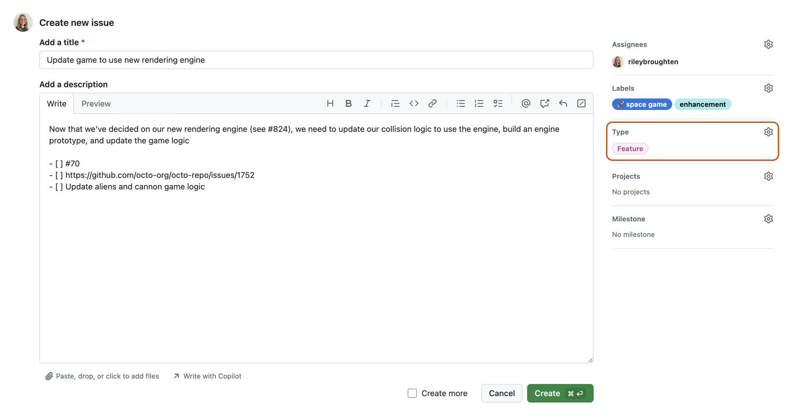
docs.github.com
- If labels are available, add an appropriate label such as bug, investigation, or operations. If those labels do not exist, you can skip this step.
- Observe the issue number assigned by GitHub.
What is the difference between an issue and a runbook?
- The runbook explains how to investigate a type of problem.
- The issue tracks a particular investigation or follow-up task.
- The pull request proposes a change to the runbook.
- The commit records a change to the repository.
This distinction is important in IT Operations because teams need both reusable procedures and records of individual incidents.
Checkpoint: Open the issue and verify that its title, investigation checklist, and runbook reference are visible.

Step 7 — Final validation (8 minutes)
Objective: Confirm that all required deliverables exist.
Open the repository's main branch and check the following:
- The repository is named aiops-operations-runbooks.
- The repository contains README.md.
- The repository contains runbooks/high-cpu-utilization.md.
- The runbook contains the initial investigation steps and diagnostic examples.
- The recovery checklist and post-incident review section are present.
- The commit history shows the recorded changes.
- The pull request is merged, if repository permissions allow it.
- The incident-tracking issue exists.
Finally, copy your repository URL and issue URL into your training notes. These are the references you would share with the trainer to demonstrate completion.

5. Troubleshooting guide
Use this section if participants get stuck while completing the lab independently.
Problem | What to do
Cannot create a repository | Check whether the account or organization permits repository creation. Ask the trainer for an approved training repository.
Cannot find “Create new file” | Open the repository's Code tab, then select Add file → Create new file.
Branch option is missing | Return to the repository's Code page and use the branch selector. Confirm that you have write access.
File changes appear on main instead of the feature branch | Check the selected branch before editing. If necessary, recreate the exercise in a feature branch.
Pull request shows no changes | Confirm that the base is main and the compare branch is feature/improve-cpu-runbook.
Cannot merge the pull request | Check permissions, required approvals, and status checks. Ask the trainer or repository administrator for help.
Issues tab is missing | Issues may be disabled for the repository or restricted by organizational policy. Ask the trainer to enable the feature or use an approved alternative.
Markdown formatting looks incorrect | Check that headings begin with #, list items use the correct syntax, and code examples use consistent indentation.

6. Knowledge check
Ask participants to answer these questions individually in the final few minutes.
1. What is the primary purpose of a GitHub repository?
To run production servers
To store project files and track their version history
To replace an incident management platform
2. Why did we create a feature branch?
To permanently duplicate the repository
To avoid recording changes
To develop and review proposed changes separately from main
3. What does a commit represent?
A recorded snapshot of repository changes
An alert sent to an operations team
A cloud server deployment
4. What is the purpose of a pull request?
To delete a branch automatically
To propose and review changes before merging them
To create a production CPU alert
5. Which GitHub feature did we use to track the simulated incident?
Git LFS
A pull request
An issue
Check answers

7. Expected deliverables
By the end of the two-hour lab, each participant should have produced the following:
GitHub repository
aiops-operations-runbooks
Operational runbook
runbooks/high-cpu-utilization.md with investigation, diagnostics, recovery, and post-incident review sections.
Feature branch and pull request
A proposed change reviewed and merged into main, where permissions allow.
Incident issue
A tracked investigation with actionable checklist items.

8. How this connects to AIOps
This first lab intentionally focuses on the foundation rather than implementing machine learning or automatic remediation immediately.

Operational runbook
Document repeatable troubleshooting procedures
>>
Version control and peer review
Track changes and improve procedures safely
>>
Incident tracking
Record investigation tasks and outcomes
>>
Next steps: automated operations
Build on this foundation with data processing, anomaly detection, and GitHub Actions in later modules.

